CS 2302 Lab Report

Lab 1_Option B

Jose Lujan

Lab_1 Option B

Objective of the Lab: In this lab I had to work with arrays, it will populate the array depending on the name of the file. If the file name was greater than 0.5 it will go to a certain array and if its lower it will go to the other array. The point of creating two arrays is to know which files belong to the dogs photos and which ones belong to the cats photos.

Solution:

import os  
import random  
  
  
def get_dirs_and_files(path):  
 dir_list = [directory for directory in os.listdir(path) if os.path.isdir(path + '/' + directory)]  
 file_list = [directory for directory in os.listdir(path) if not os.path.isdir(path + '/' + directory)]  
 return dir_list, file_list  
  
  
def classify_pic(path):  
 # To be implemented by Diego: Replace with ML model  
 if 'dog' in path:  
 return 0.5 + random.random() / 2  
 return random.random() / 2  
  
  
def process_dir(path):  
 dir_list, file_list = get_dirs_and_files(path)  
  
 cat_list = []  
 dog_list = []  
  
 # Your code goes here  
 if len(dir_list) > 0:  
 for d in range(len(dir_list)):  
 cat_pictures, dog_pictures = process_dir(path + '/' + dir_list[d])  
 for j in range(len(cat_pictures)):  
 cat_list.append(cat_pictures[j])  
 for k in range(len(dog_pictures)):  
 dog_list.append(dog_pictures[k])  
 for d in range(len(file_list)):  
 if classify_pic(path + '/' + file_list[d]) >= 0.5:  
 dog_list.append(path + '/' + file_list[d])  
 else:  
 cat_list.append(path + '/' + file_list[d])  
  
 return cat_list, dog_list  
  
  
def main():  
 start_path = './' # current directory  
  
 cats_files, dogs_files = process_dir(start_path)  
  
 # Loop to print  
 if len(cats_files) > 1:  
 for i in range(len(cats_files)):  
 print(cats_files[i])  
 else:  
 print('there are no available cats to adopt! ')  
 if len(dogs_files) > 1:  
 for j in range(len(dogs_files)):  
 print(dogs_files[j])  
 else:  
 print('There are no available dogs to adopt!')  
  
  
main()

Testing :

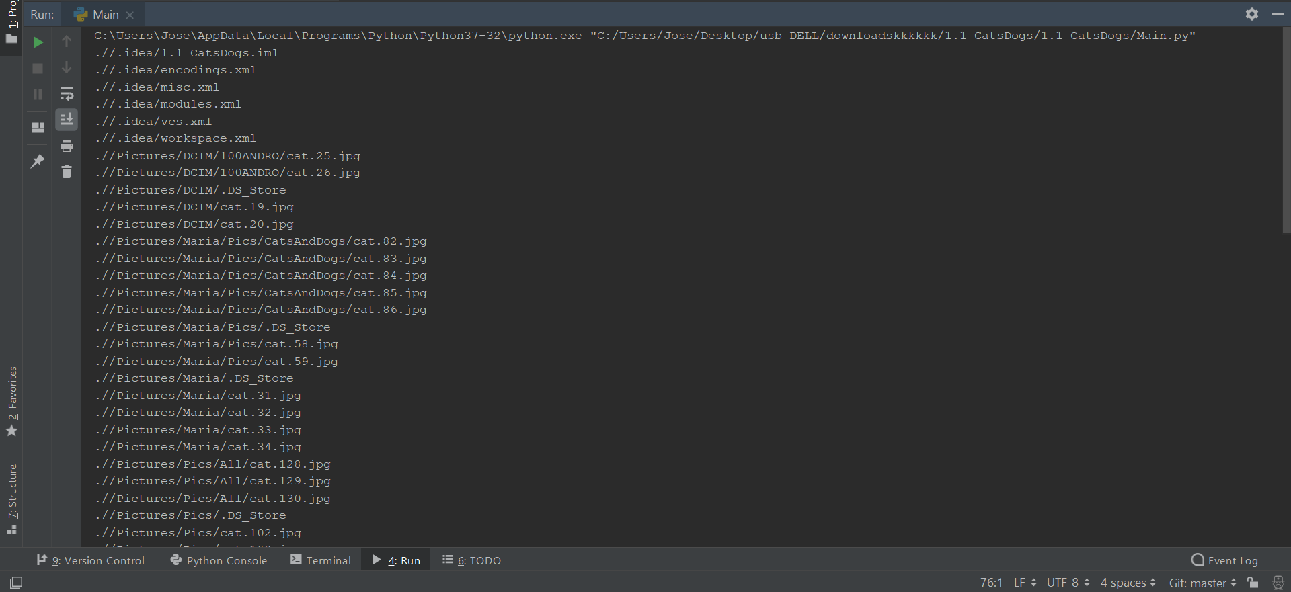

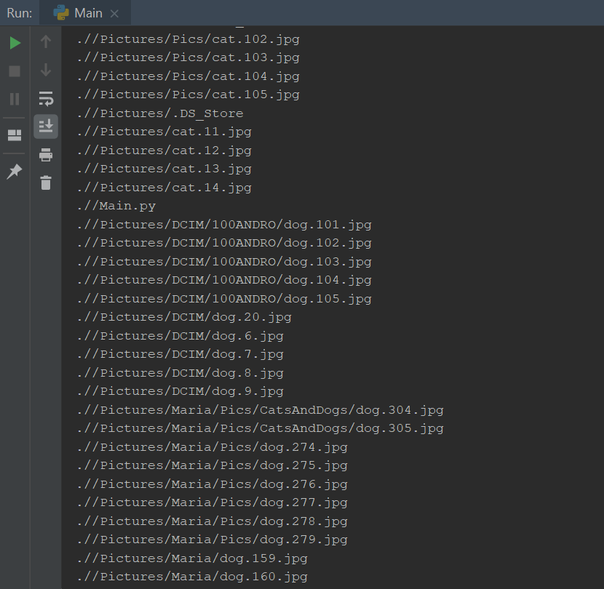

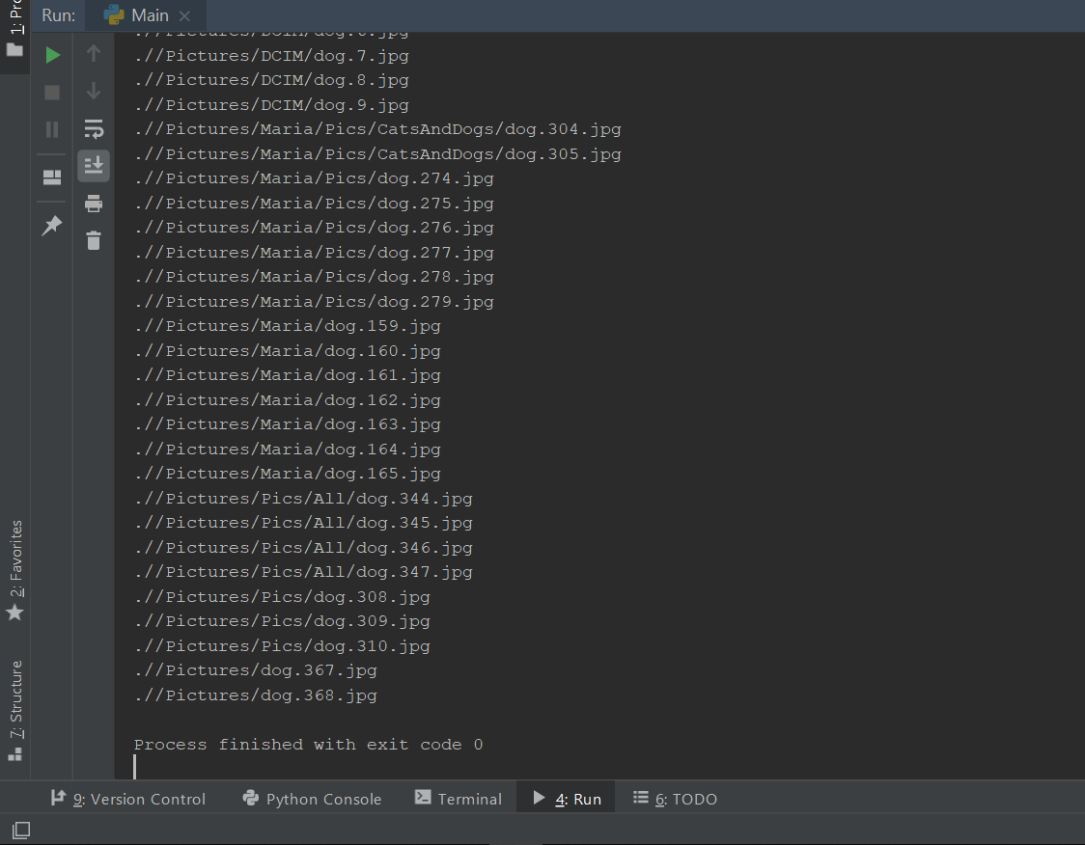

**Conclusion:**

For this lab I just had to use a for loop, which will go first through the first folder and classify the pictures, when done it will enter a second for loop. What the second for loop does, is to change from one folder to the other once it finish searching and classifying all the photos that are in the same directory or path file .